The Topic Mindmap

**Topic:** Research on Chest X-rays to deduct various respiratory infections

1) **Analyzing the image**

X-ray images as a doctors frequently use X-rays and CT scans to diagnose pneumonia, lung inflammation, abscesses, and enlarged lymph nodes. Since COVID-19 attacks the epithelial cells that line our respiratory tract, we can use X-rays to analyse the health of a patient’s lungs. To analyse the X-ray images we should know the different parts of the X-rays for example if the lungs filled with total air then what it will show in X-ray, what if we have bone fractures inside the lungs. What will be the identification of other tissues, normally Air appears black, fat appears gray, soft tissues and water appear as lighter shades of gray, and bone and metal appear white. The denser the tissue, the whiter it will appear on x-ray. Denser tissues appear radiopaque, bright on the film; less dense tissues appear radiolucent, dark on the film.

Chest x-ray review is a key competency for medical students, junior doctors and other allied health professionals. Using A, B, C, D, E is a helpful and systematic method for chest x-ray review:

A: airways

B: breathing (the lungs and pleural spaces)

C: circulation (cardiomediastinal contour)

D: disability (bones - especially fractures)

E: everything else, e.g. pneumoperitoneum

2) **Image noise**

If we have Image noise for our dataset what we have to do? What is the percentage of noise on the image? How we have to reduce that noise level on the image?

The common types of noise that are present in x-ray images are Poisson noise, salt and pepper noise, and speckle noise. The salt and pepper is seen in the image as white and black pixels respectively. Poison noise is as a result of uneven distribution of x-rays over the receptor surface. Speckle noise on the other hand occurs as a granular appearance in an image which is produced as a result of random fluctuations in the return signal from an object which is not found to be bigger than a single image processing element. Within a specific area, speckle noise is able to increase the mean grey level.

An image pre-processing step can improve the accuracy of machine learning models. Pre-processed images can help a basic model achieve high accuracy when compared to a more complex model trained on images that were not pre-processed. For Python, the Open-CV and PIL packages allow you to apply several digital filters. Applying a digital filter involves taking the convolution of an image with a kernel (a small matrix). A kernel is an n x n square matrix were n is an odd number. The kernel depends on the digital filter.

We have different types of techniques to remove the noise inside the image such as

* Mean filter
* Gaussian Filter
* Median Filter (Highly recommended filter to remove Salt and pepper noise)
* Other Filters

3) **Covid-19 and Pneumonia**

After having the denoised image dataset, I have to find the infected X-rays and distinguish whether that X-ray will match with Covid-19 or Pneumonia. We have different types of Convolution neural networks available to train and test the data set. Before creating the neural network we have to do data augmentation so that we can increase the accuracy rate in this experiment. We have to divide the given dataset for both training and testing so, that we can complete easily identify the disease when compare with normal X-rays. After having the algorithm to test the specific disease we will have to create one test function whether we are predicting correct disease by passing random images to that function. Another main work is to find the accuracy of the network whether we achieved our goal with statistics graph visualise or we can develop the function to check whether we deducted infected area of the X-rays. Severity is also one main concern in real time world to deduct and consult the doctor based on it.

As per my research I see the radiologists rated pulmonary parenchymal involvement using a semi quantitative severity score, subdividing each lung into three zones upper zone (from the lung apex to the aortic arch profile), middle zone (from the aortic arch profile to the lower margin of the left pulmonary hilum), and lower zone (from the lower margin of the left pulmonary hilum to the diaphragm). For each zone, a score on a scale from zero to three in 1-point increments was assigned: 0, normal lung parenchyma; 1, interstitial involvement only; 2, presence of radiopacity for less than 50% of the visible lung parenchyma; 3, presence of radiopacity for 50% or more than 50% of the visible lung parenchyma.

Based on the Scale inputs given by the radiologists we have to give random images or X-rays to severity function to measure and show the severity rate of the X-ray when compare to the normal human X-ray before effecting that infection.

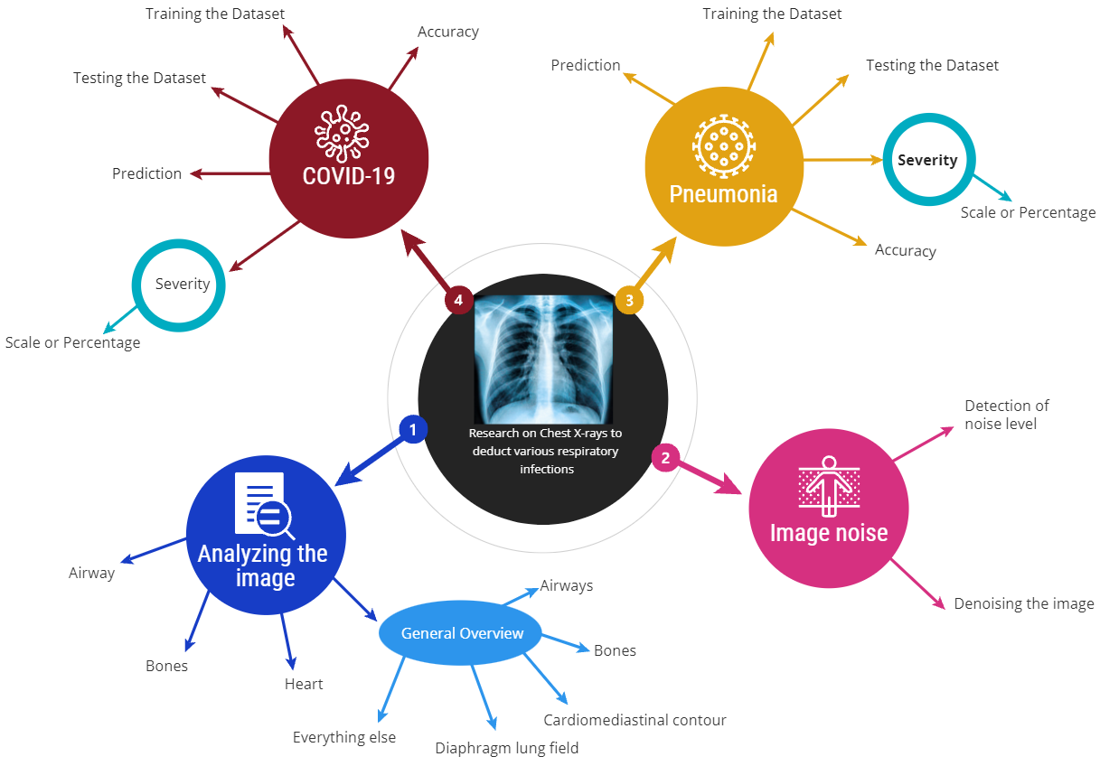The below image represents my Research project Mindmap